Sistemas Informáticos (Computer Systems)  
Unit 06. Activities 01

short line

Authors: Sergi García, Alfredo Oltra

Updated October 2022

Unit 06. Activities 01

# Exercise 01

Create an account called “miCompiExperto” with administrator profile and an account called “miCompiPeligroso” with normal user profile.

# Exercise 02

Try to delete Windows folder with Account “miCompiPeligroso”. What happens?

# Exercise 03

Configure Windows 10 to update manually. How can you search for updates with that configuration?

# Exercise 04

Use Disk manager to shrink your disk. Use them to expand your disk again.

# Exercise 05

Deactivate a device. What happens? Activate it again.

# Exercise 06

Configure BitLocker to cipher a partition.

# Exercise 07

Update Windows Defender and run a quick scan.

# Exercise 08

Use msconfig to:

* Disable (and later enable) a service (for example, Windows Audio).
* Disable (and later enable) a program that is run on Windows start.

# Exercise 09

Using console:

* Create the file and directory structure shown in the picture of this exercise.
* Store in a file “c:\temp_SI\data.txt” the name of all files of the created structure.
* Store in a file “c:\temp_SI\dataWithA.txt” the name of all elements with an A in his name of the created structure.
* Order “data.txt” file by name in “data_ordered.txt” (relative path).
* Order “dataWithA.txt” file by name in “data_orderedWithA.txt” (relative path).
* Set attributes of “data.txt” (relative path) to hidden and read only.
* Set attributes of “dataWithA.txt” (relative path) to system.

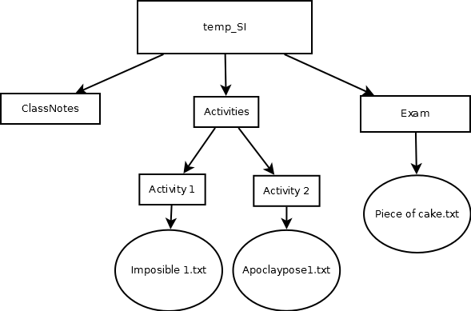

1. Exercise 10

Create an administrator user named "test" with a password of your choice. Suppose you have lost the password.

Use the "Rescatux" LiveCD/USB http://www.supergrubdisk.org/rescatux to set the password of that user to blank so that you can access it. After that, remove the user from the system.

1. Exercise 11

Explain what the commands “md” and “cd” (including “cd”, “cd ..” and “cd .”) are for.

1. Exercise 12

Explain what the wildcard characters "*" and "?" are for. Give 3 examples of the use of each of them and one that combines both at the same time.

1. Exercise 13

Solve the following exercises with a single command and using relative paths:

* Assuming you are in C:\EXERCISE, what command would you use to create a folder called "practice" in C:EXERCISE.
* Assuming you are in C:\EXERCISE, what command would you use to change to the C:\EXERCISE directory?
* Assuming you are in C:\SI, what command would you use to view the contents of the "practice" directory inside C:\SI?
* Assuming you are in C:\SI, what command would you use to delete the directory C:\SI, knowing also that this directory contains other directories and files.
* Assuming you are in C:\EXERCISE, what command would you use to see the content of the text file "exercise1.txt" which is in C:\Exercise1.txt.
* Assuming you are in c:\EXERCISE, what command would you use to delete all the files in c:\EXERCISE with extension "txt" that begin with the letter "a".
* Assuming you are in C:\EXERCISE, what command would you use to copy the file "exercise3.txt" that is in C:\EXERCISE to E:\EXERCISE.
* Assuming you are in C:\EXERCISE, what command would you use to move the file "exercise4.txt" that is in C:\EXERCISE to C:\Exercises.txt?